create database insurance_CS154;

use insurance_CS154;

create table insurance_CS154.person(

driver_id varchar(20),

name varchar(30),

adress varchar(50),

PRIMARY KEY(driver_id)

);

create table insurance_CS154.car(

reg_num varchar(15),

model varchar(10),

year int,

PRIMARY KEY(reg_num)

);

create table insurance_CS154.accident(

report_num int,

accident_date date,

location varchar(50),

PRIMARY KEY(report_num)

);

create table insurance_CS154.owns(

driver_id varchar(20),

reg_num varchar(10),

PRIMARY KEY(driver_id,reg_num),

FOREIGN KEY(driver_id)REFERENCES person(driver_id),

FOREIGN KEY(reg_num)REFERENCES car(reg_num)

);

create table insurance_CS154.participated(

driver_id varchar(20),

reg_num varchar(10),

report_num int,

damage_amount int,

PRIMARY KEY(driver_id,reg_num,report_num),

FOREIGN KEY(driver_id)REFERENCES person(driver_id),

FOREIGN KEY(reg_num)REFERENCES car(reg_num),

FOREIGN KEY(report_num)REFERENCES accident(report_num)

);

desc person;

desc accident;

desc participated;

desc car;

desc owns;

insert into person values("A01","Richard","Srinivas nagar");

insert into person values("A02","Pradeep","Rajaji nagar");

insert into person values("A03","Smith","Ashok nagar");

insert into person values("A04","Venu","N R Colony");

insert into person values("A05","John","Hanumanth nagar");

select * from person;

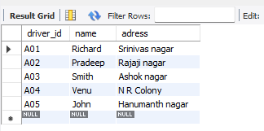

insert into car values("KA052250","Indica","1990");

insert into car values("KA031181","Lancer","1957");

insert into car values("KA095477","TOYOTA","1998");

insert into car values("KA053408","Honda","2008");

insert into car values("KA041702","Audi","2005");

select * from car;

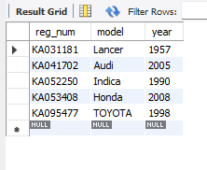

insert into owns values("A01","KA052250");

insert into owns values("A02","KA031181");

insert into owns values("A03","KA095477");

insert into owns values("A04","KA053408");

insert into owns values("A05","KA041702");

select * from owns;

insert into accident values(11,'2003-01-01',"Mysore Road");

insert into accident values(12,'2004-02-02',"South end Circle");

insert into accident values(13,'2003-01-21',"Bull temple road");

insert into accident values(14,'2008-02-17',"Mysore Road");

insert into accident values(15,'2004-03-05',"Kanakpura Road");

select * from accident;

insert into participated values("A01","Ka052250",11,10000);

insert into participated values("A02","KA053408",12,50000);

insert into participated values("A03","KA095477",13,25000);

insert into participated values("A04","KA031181",14,3000);

insert into participated values("A05","KA041702",15,5000);

select * from participated;

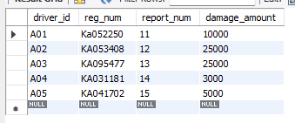

update participated

set damage_amount=25000

where reg_num='KA053408' and report_num=12;

select count(distinct driver_id) CNT

from participated a, accident b

where a.report_num=b.report_num and b.accident_date like '2008%';

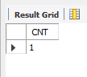

insert into accident values(16,'2008-03-08','Domlur');

SELECT * FROM PARTICIPATED ORDER BY DAMAGE_AMOUNT DESC;

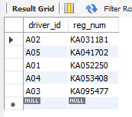

select accident_date,location from accident;

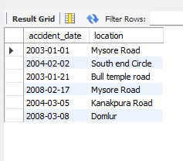

SELECT * FROM PARTICIPATED ORDER BY DAMAGE_AMOUNT DESC;

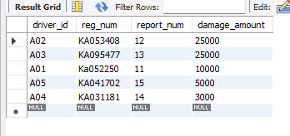

DELETE FROM PARTICIPATED WHERE

DAMAGE_AMOUNT < (SELECT AVG (DAMAGE_AMOUNT) FROM (select avg(damage_amount) as avg_damage from PARTICIPATED);

SELECT NAME FROM PERSON A, PARTICIPATED B WHERE A.DRIVER_ID = B.DRIVER_ID AND

DAMAGE_AMOUNT > (SELECT AVG(DAMAGE_AMOUNT) FROM PARTICIPATED);

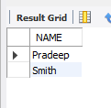

SELECT MAX(DAMAGE_AMOUNT) FROM PARTICIPATED;

